**IIG Varsity**

E/43, 2nd Floor, iHub, Infocity Ave, Bhubaneswar Name of the Student

Test: **IIG-FND-001**, Time: **2 hours**, Date: **11-06-2024** ____________________________________

1. Create an HTML page to add an image to the background of an HTML page. Download the image from the internet.
2. Create an HTML page to display the list of your choicest web pages. On clicking on any of the items in the choice list, it navigates to the respective page on web.
3. Develop a web page to display the following table:

|  |  |  |  |  |  |
| --- | --- | --- | --- | --- | --- |
| **Firm** | **Org** | **Lob** | **Sub Lob** | **Business Plans** | **Business Components** |
| XYZ | CST | CT | ADS | 1 | 10 |
| BTO | 2 | 15 |
| CSI | 3 | 6 |
| VCT | ADS | 4 | 10 |
| BTO | 5 | 15 |
| Sub Total | | | 6 | 15 |
| CST | CT | ADS | 7 | 10 |
| BTO | 8 | 15 |
| CSI | 9 | 6 |
| VCT | ADS | 10 | 10 |
| Sub Total | | | 11 | 15 |

1. Display the image below in your web page. On clicking on the photograph of the deligates, it navigates to their respctive page in Wikipedia?

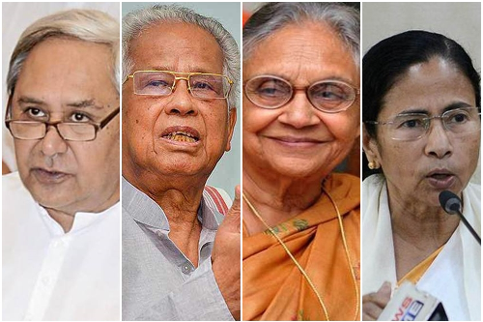

Naveen Patnaik, Tarun Gogoi, Sheila Dixit, and Mamata Banerjee. (From left to right)